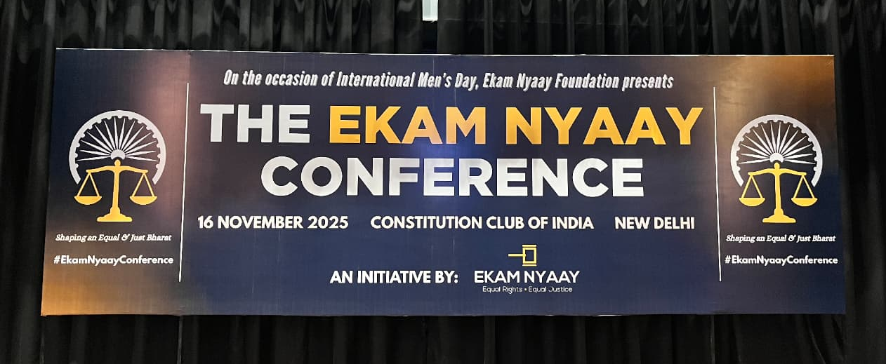

PRESS RELEASE

BEING PRO JUSTICE IS NOT BEING ANTI - WOMEN, DISCUSSION ON MISUSE OF LAWS A NEED OF THE HOUR : JUSTICE U U LALIT, FORMER CHIEF JUSTICE OF INDIA AT THE EKAM NYAAY CONFERENCE BY EKAM NYAAY FOUNDATION ORGANIZED IN DELHI IN WAKE OF INTERNATIONAL MEN'S DAY
The Constitution Club of India witnessed a powerful and deeply introspective gathering on 16 November 2025, as the Ekam Nyaay Foundation hosted its flagship event,“The Ekam Nyaay Conference – Shaping an Equal & Just Bharat.”
Keynote address at the event was delivered by Justice U U Lalit, Former Chief Justice of India who spoke on the importance of the system being sensitive that it does not prosecute and punish any innocent while it ensures justice to genuine victims. He emphasized that in cases of consensual relationships of years later reported as rape on false promise of marriage, police should not curtail the liberty of the man and arrest him immediately without investigation. He reiterated words spoken by Deepika Narayan Bhardwaj - Director Ekam Nyaay Foundation, that being pro justice does not mean being anti women. "In society if there are Sitas, there are also Shupnakhas"
The event witnessed release of Ekam Nyaay Foundation's Annual Report by Justice U U Lalit and Justice Sadhana Jadhav, Former Judge, Bombay High Court.
Organized in the spirit of International Men’s Day that is celebrated on 19th November, the conference initiated meaningful dialogue and acknowledged the critical yet often overlooked issues faced by men in today’s socio-legal landscape. With its unwavering commitment to justice beyond gender, Ekam Nyaay Foundation brought together legal experts, policymakers, activists, filmmakers, and survivors to collectively re-imagine a more equitable justice system.
With its central commitment to gender-neutral justice, the conference became a platform for conversations India has long avoided misuse of laws, parental alienation, mental health crises among men and the social stigma surrounding male victimhood. The event opened to a full auditorium at the historic Mavlankar Hall, setting the stage for a day of intense dialogue, testimonies, and calls for systemic reform.
Delivering the keynote address as Chief Guest, Former Chief Justice of India, Justice Uday Umesh Lalit, set the tone for the day with remarkable clarity. He emphasized that the conversation around men’s issues is not an attack on women’s rights but an essential demand for a fair and balanced justice system. “We are not anti-women; we are pro-justice,” he appreciated Deepika Narayan Bhardwaj's key statement , urging institutions to acknowledge the growing number of men who find themselves trapped in false accusations, procedural lapses, and unequal social expectations.
Justice Lalit spoke candidly about the gaps in India’s policing and criminal jurisprudence. Highlighting the urgent need for structural reform, he advocated for separate investigative and law-and-order wings, pointing out that overburdened police personnel lack the tools and time to conduct nuanced investigations in sensitive cases. He drew from the Ramayana in a striking analogy, noting, “There are many Sitas in our world, but so are the Supranakhas.” He emphasized that the legal system must create mechanisms that protect the innocent and punish misuse of laws with equal seriousness. He further stressed that in cases of rape, a survivor’s statement is treated as “almost gospel” but if such an accusation is proven false, there must be a single trial mechanism to hold the false accuser accountable with the same rigour.
Guest of Eminence Justice Smt. Sadhana Sanjay Jadhav, former Judge of the Bombay High Court, delivered one of the most thought-provoking addresses of the day. She questioned long-held assumptions, particularly the idea that a woman “would never humiliate herself” by making a false allegation. “Why would she? But I ask, why not?” she said, urging society to acknowledge the complexity of human behaviour and the reality of malicious allegations. Drawing attention to the collateral damage inflicted by false charges, she said, “When a man is accused, it’s not he alone who suffers. It is his children, his parents, his siblings, his entire world.”
She praised the relentless work of Ekam Nyaay, calling it “an awakening” that India needs, an effort to reshape mindsets and challenge social conditioning that assumes male guilt as default.
Ekam Nyaay’s founder, Deepika Narayan Bhardwaj, while presenting the work done by the organisation in the last one year stated “We work with men and their families who are shattered because of false accusations on a daily basis. We Hold Their Hands from the Moment They Break down. Our Foundation works at the grassroots level holding the hands of men who have hit rock-bottom after false allegations, police apathy, or prolonged litigation. So many men and their parents call us, unable to breathe under the pressure of stigma. We guide them through FIRs, courtrooms, and society’s unforgiving judgments." Sharing numbers from the last year's work, Bhardwaj said " We counselled more than 2000 men, enabled arrest of 37 criminals and false accusers, enabled FIR from victim families in 24 cases, conducted 3 major researches, got more than 123 articles published in print and digital media and our content had more than 700M+ views across social media platforms.
Throughout the day, several other speakers , lawyers, psychologists, journalists, and activists took the stage to discuss issues ranging from mental health and rising male suicides to parental alienation, misuse of rape laws, and the urgent need for prenuptial agreements in India. In a lighter yet piercing moment, Sh. Satya Prakash Rai , Former Additional Director of Prosecution, UP Govt remarked: “Victims ka koi gang nahi hota.”
A simple line, but one that captured the loneliness of men navigating false accusations without societal support.
As the day concluded, the message was unmistakable: men’s issues are human issues, and justice cannot be selective. The Ekam Nyaay Conference served not as a counterpoint to women’s rights but as an essential expansion of India’s justice discourse towards a future where gender does not determine whose voice is heard.

FULL TEXT OF SPEECH BY JUSTICE UU LALIT :
Police officers or the investigation officers in our country do not have the kind of professional equipment or education that is needed and the force deserves and that was also stated in the judgment of Prakash Singh, that we must segregate the investigative wing from the wing of normal law and order issues. The rate of conviction has never been more than 20%. All the undertrials, 4 out of 5 persons will be acquitted. Are we not taking someone in custody who would be found to be innocent or crime did not get proved against him. Where does society stand? Should we not insulate our system in such a way that innocent people are not run after and given a chase for life by the end of which they are left gasping for life.
Doesn't society owe to such persons what is legally and morally due to them. And that is what is the logic of Ekam Nyaay. What Deepika Narayan Bhardwaj said - we are not anti women, that's exactly the point. There are Sita maiyas but there are surpnakhas as well in the society. So therefore one has to as a society be circumspect and galvanize your machinery in a manner that leaves out chances of innocents being dragged to the court, innocent getting prosecuted and innocent getting tired of the entire process. The level to which the jurisprudence has gone states that the statement by the victim when it comes to charges under 376 or rape case, should be given highest respect. That is understandable. But then maybe our system should be such that if there is a false accusation then the charge of false prosecution or malicious prosecution should not be left for a second kind of trial to be undertaken after the conclusion of the first one but a finding can recorded by the presiding officer of the court that the false accuser must be punished. These kinds of safety valves at every juncture, at the stage of investigation, at the stage of conducting of trial, at the stage of enquiry by the magistrate.
Many a times what we find is that young girls and boys enter into relationship with open eyes, something goes wrong and after a year or two comes a complaint that I was taken advantage of by this man and then the proceedings begin where the context given is that on the pretext of marriage I was taken advantage of so therefore it becomes a charge under IPC 376 or rape. Now there could be some truth in that complaint. But at the same time there are shades of grey as well. And in that grey, the system should make sure that an innocent person should not be prosecuted or be subjected to unnecessary arrest. Now in matters such as this, how is the arrest of the man going to further the cause of investigation? Some things may have happened a year or two years ago - but now, day in day out we find that the investigators are arresting and curtailing the liberty of that person.
These are issues that need a deeper kind of understanding and conferences such as The Ekam Nyaay Conference , this is exactly what is the need of society, need of the hour and this is what the society demands that we must give attention to these spheres of life. And that's what this conference intends to do and seeks to achieve. This amrit manthan may lead to changes that are the need of the society, for the betterment and good of society and for the cause of Justice.
I must congratulate the organizers and Deepika ji in particular for organizing this conference. I wish them all the best.

